Navigate the News Landscape

**Team leader:** Selshiya X

**Team Members:**

1. Santhiya
2. Sathya
3. Shruthi Laya

**Introduction:**

InsightStream emerges as a pioneering web platform poised to redefine the landscape of news consumption, seamlessly blending an intuitive interface with advanced search functionalities and a comprehensive array of news categories, catering to the diverse preferences of readers. Join us on this transformative journey and immerse yourself in a new epoch of information engagement that places you at the epicenter of news exploration

**Description:**

* Welcome to the vanguard of news exploration with InsightStream! Our innovative web application is meticulously designed to transcend the confines of traditional news consumption, catering to the diverse interests of avid news enthusiasts and seasoned information seekers alike. With a strong emphasis on delivering a seamless user experience and a comprehensive suite of features, InsightStream is poised to fundamentally transform the manner in which news is accessed and engaged with.
* Engineered for usability and aesthetic appeal, InsightStream provides users with an unparalleled journalistic experience. Effortlessly traverse a vast array of news categories, utilizing advanced tools such as dynamic search functionality to access the most recent and pertinent stories from around the globe.
* Whether your interest lies in breaking news or in-depth exploration of specialized topics, InsightStream addresses a broad demographic, fostering a vibrant community united by a collective commitment to remaining informed. Our mission is to redefine the interaction with news, offering a platform that not only presents the latest headlines but also encourages collaboration and engagement within a flourishing news community.

**Scenario Based Intro:**

After a hectic day, you’re walking home, eager to catch up on the news. You remember InsightStream, the app you recently downloaded. Curious, you open it up. Instantly, you're greeted with breaking headlines and dynamic visuals that stand out from the usual news feed. You tap on a category and dive into a world of engaging, in-depth stories. InsightStream isn’t just another news app—it’s a whole new way to stay informed.

**Technical Architecture:**

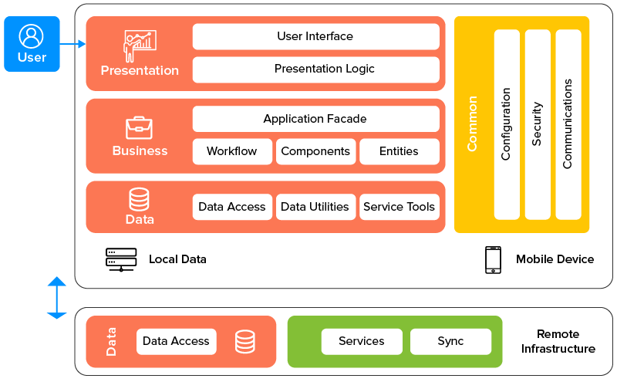

The user journey begins with the InsightStream web application’s interface, which is likely developed using a modern framework like React or Vue.js to ensure a seamless, single-page application experience. The UI communicates with an API client built specifically for InsightStream, which manages the interaction with the backend. What sets it apart is the integration of Rapid API, a platform that connects to a wide range of external APIs. This allows InsightStream to enhance its functionality and data sources without the need to develop every feature internally, offering a richer and more diverse user experience.

**Project Goals and Objectives:**

**The primary ambition of InsightStream is to develop an intuitive digital platform meticulously crafted for individuals keen on remaining informed, exploring a diverse array of news topics, and gaining access to the latest information. Our principal objectives encompass:**

* **Facilitating an Intuitive User Experience by designing a user interface that promotes effortless navigation, enabling users to seamlessly discover, save, and share their preferred news articles.**
* **Implementing Comprehensive Content Management through the provision of robust tools for organizing and managing news articles, complemented by advanced search functionalities that personalize the news consumption experience for each user.**

**Leveraging an Advanced Technology Stack by incorporating cutting-edge web development technologies, such as React.js, to ensure a browsing experience that is not only fast and efficient but also highly enjoyable.**

**Features of InsightStream:**

* **Global News from API Sources:** Gain access to a wide range of news from trusted global sources, covering diverse categories and topics to ensure comprehensive coverage of current events.
* **Visual News Discovery:** Explore breaking stories and browse different news categories through curated image galleries, enhancing the visual aspect of news consumption.
* **User-Friendly Interface:** Enjoy smooth navigation with a clean, modern design that ensures an intuitive and seamless user experience while presenting information clearly.
* **Powerful Search Functionality:** Quickly find news articles on specific subjects with an advanced search feature, delivering personalized content based on your interests.

**PRE-REQUISITES:**

Here are the key prerequisites for developing a frontend application using React.js:

* **Node.js and npm:**

Node.js is a powerful JavaScript runtime environment that allows you to run JavaScript code on the local environment. It provides a scalable and efficient platform for building network applications.

Install Node.js and npm on your development machine, as they are required to run JavaScript on the server-side.

● Download: <https://nodejs.org/en/download/>

● Installation instructions: https://nodejs.org/en/download/package-manager/

* **React.js:**

React.js is a popular JavaScript library for building user interfaces. It enables developers to create interactive and reusable UI components, making it easier to build dynamic and responsive web applications.

Install React.js, a JavaScript library for building use

● Create a new React app:

npx create-react-app my-react-app

Replace my-react-app with your preferred project name

● Navigate to the project directory:

cd my-react-app

● Running the React App:

With the React app created, you can now start the development server and see your React application in action.

● Start the development server:

npm start .This command launches the development server, and you can access your React app at <http://localhost:3000>

in your web browser.

* **HTML, CSS, and JavaScript:**

Basic knowledge of HTML for creating the structure of your app, CSS for styling, and JavaScript for client-side interactivity is essential.

* **Version Control:**

Use Git for version control, enabling collaboration and tracking changes throughout the development process. Platforms like GitHub or Bitbucket can host your repository.

• Git: Download and installation instructions can be found at: https://git-scm.com/downloads

* **Development Environment:**

Choose a code editor or Integrated Development Environment (IDE) that suits your preferences, such as Visual Studio Code, Sublime Text, or WebStorm

.

• Visual Studio Code: Download from https://code.visualstudio.com/download

• Sublime Text: Download from <https://www.sublimetext.com/download>

• WebStorm: Download from <https://www.jetbrains.com/webstorm/download>

To install and run the Application project from google drive:

Follow below steps:

* **Get the code:**

• Download the code from the drive link given below: <https://drive.google.com/drive/folders/1tDoSwd-1I3HsPJ9_92MnZTUtteeda-hL?usp=sharing>

* **Install Dependencies:**

• Navigate into the cloned repository directory and install libraries:

cd news-app-react npm install

* **Start the Development Server:**

• To start the development server, execute the following command:

npm start

* **Access the App:**

• Open your web browser and navigate to <http://localhost:3000>.

• You should see the applications homepage, indicating that the installation and setup were successful.

. You have successfully installed and set up the application on your local machine. You can now proceed with further customization, development, and testing as needed.

**Project structure:**

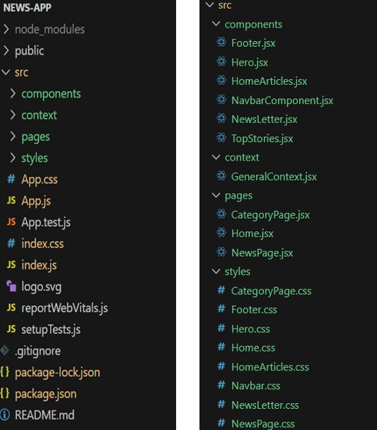

In this project, we’ve split the files into 4 major folders, Components, Context, Pages and Styles. In the pages folder, we store the files that acts as pages at different URLs in the application. The components folder stores all the files, that returns the small components in the application. The context Api will be coded in the context folder. All the styling css files will be stored in the styles folder.

**Project Flow:**

Project demo: Before starting to work on this project, let’s see the demo.

Demo link: <https://drive.google.com/file/d/1i8y09FiMk7QM0akH3my10OBWqXH-8dNh/view?usp=sharing>

Use the code in: <https://drive.google.com/drive/folders/1tDoSwd-1I3HsPJ9_92MnZTUtteeda-hL?usp=sharing>

**Milestone 1: Project setup and configuration**

● **Installation of required tools:**

To build InsightStream, we'll need a developer's toolkit. We'll use React.js for the interactive interface, React Router Dom for seamless navigation, and Axios to fetch news data. For visual design, we'll choose either Bootstrap or Tailwind CSS for pre-built styles and icons.

Open the project folder to install necessary tools. In this project, we use:

* React Js
* React Router Dom
* React Icons o Bootstrap/tailwind css
* Axios

● For further reference, use the following resources

* https://react.dev/learn/installation
* <https://react-bootstrap-v4.netlify.app/getting-started/introduction>
* <https://axios-http.com/docs/intro>
* <https://reactrouter.com/en/main/start/tutorial>

**Milestone 2: Project Development**

❖ Setup the Routing paths Setup the clear routing paths to access various files in the application.

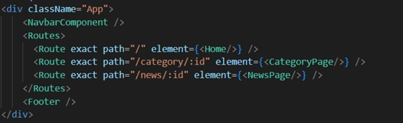

❖ Develop the Navbar and Hero components

❖ Code the popular categories components and fetch the categories from newsapi.

❖ Also, add the trending news in the home page.

❖ Additionally, we can add the component to subscribe for the newsletter and the footer.

❖ Now, develop the category page to display various news articles under the different categories.

**Important Code snips:**

**Fetching Top/Trending news**

With the API request, we fetch the trending news articles.

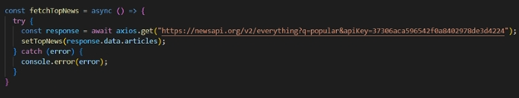

The code snippet shows a function written in Python called fetchTopNews that fetches news articles from an API. Here's a breakdown of the code:

***Async function fetchTopNews:***

The code defines an asynchronous function named fetchTopNews. An asynchronous function is used to handle asynchronous operations, such as making API requests that take time to complete.

*try...catch block:*

● The try...catch block is used to handle the API request.

● The try block contains the code that attempts to fetch data from the API using axios.get.

. ● axios is an external Python library for making HTTP requests. If you don't already use Axios in your project, you'll need to install it using a package manager like pip.

● The get method makes a GET request to the specified url.

**Fetching news by search/category**

With the specific category or search keyword, we use API request to fetch all the news articles related to that.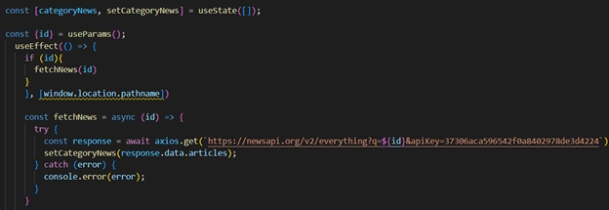

The code snippet shows a function called get_news_articles that fetches news articles from a news API.

Here's a breakdown of the code:

**Imports:**

The code starts by importing the requests library. The requests library is a popular Python library for making HTTP requests. If you don't already have it installed in your project, you can install it using pip install requests.

**API Key:**

The line API_KEY = 'YOUR_API_KEY' defines a variable named API_KEY and assigns it a placeholder value 'YOUR_API_KEY'. You should replace this with a placeholder instructing users to replace it with their own API key obtained from the news API provider they want to use.

**Function Definition (get_news_articles):**

The code defines a function named get_news_articles that takes two parameters:

● query: This parameter is likely a string representing the search query for news articles.

● source: This parameter is likely a string representing the news source (e.g., 'bbc-news', 'cnn').

**Building the API Request URL:**

The line url = f'https://newsapi.org/v2/everything?q={query}&apiKey={API_KEY}' constructs the URL for the API request using a formatted string literal (f-string).

**The URL includes the following parts:**

●Base URL: <https://newsapi.org/v2/everything>

● Query parameters:

● q: This parameter is set to the query argument passed to the function.

● apiKey: This parameter is set to the API_KEY variable, which should contain the user's API key.

**Making the API Request (requests.get):**

The line response = requests.get(url) sends a GET request to the API URL constructed earlier. The requests.get function from the requests library is used to make the HTTP request. The response from the API is stored in the response variable. Error Handling (try...except block): ● The try...except block is used to handle potential errors during the API request. ● The try block contains the code that attempts to fetch data from the API using requests.get(url). ● The except block handles any exceptions that might occur during the request, such as network errors or invalid API responses. In this case, it prints an error message to the console using print(f'Error fetching news articles: {e}').

**Project Execution:**

Once the code is finalized, start the React application by running the command “npm start” or “npm run dev” if you are utilizing Vite.js.  
Below are a few screenshots of the application.

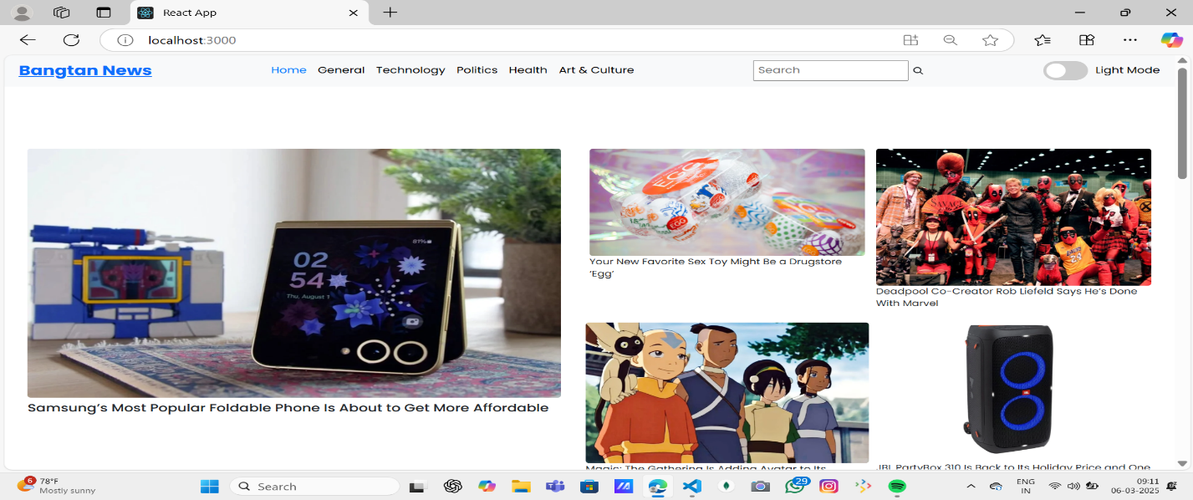**Hero Component:**  
 The hero component showcases the latest trending news articles, ensuring they stand out. Additionally, it features a search bar, allowing users to quickly search for various articles .

**Popular Categories:**

The hero component features the most popular trending news articles, designed to highlight the top stories. Additionally, it includes a search bar that allows users to quickly find specific articles and explore various categories.

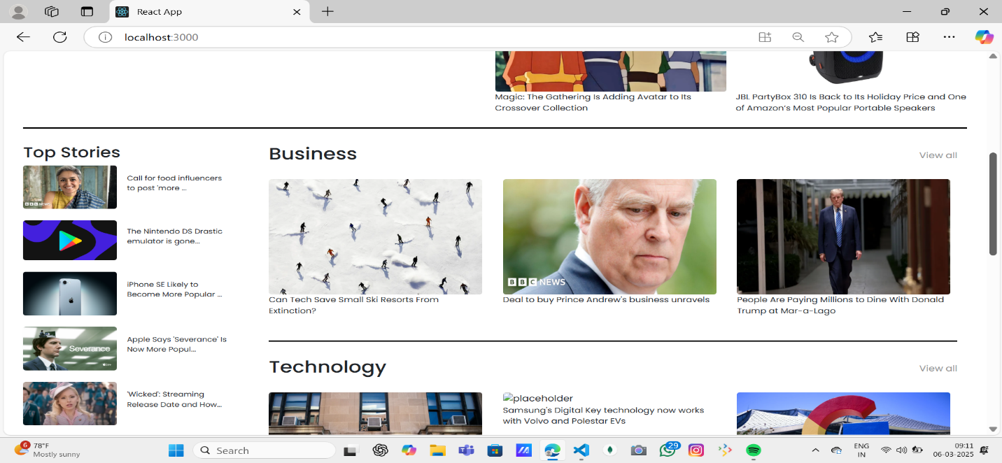

**Newsletter:**

Keeping up with the latest news is essential! This section serves as an invitation for users who wish to stay informed. A concise signup form with an email field will be provided, along with a clear call-to-action button such as "Subscribe Now" or "Receive Daily News Updates." With just one click, users can become part of the InsightStream community and get personalized news updates delivered directly to their inbox .

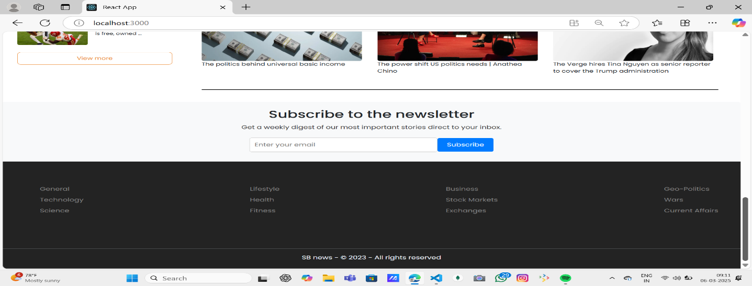

**Category/Search Result Page:**

Discovering the news you’re interested in is a breeze with InsightStream. This page presents a well-organized list of articles that match your selected category or search query. Each article features a clear headline, a brief summary, and, when available, an image to give you a quick preview of the story. To enhance your search, filters or sorting options may be available, allowing you to refine your results by date, source, keyword, or other relevant criteria, making it easier to find exactly what you're looking for.

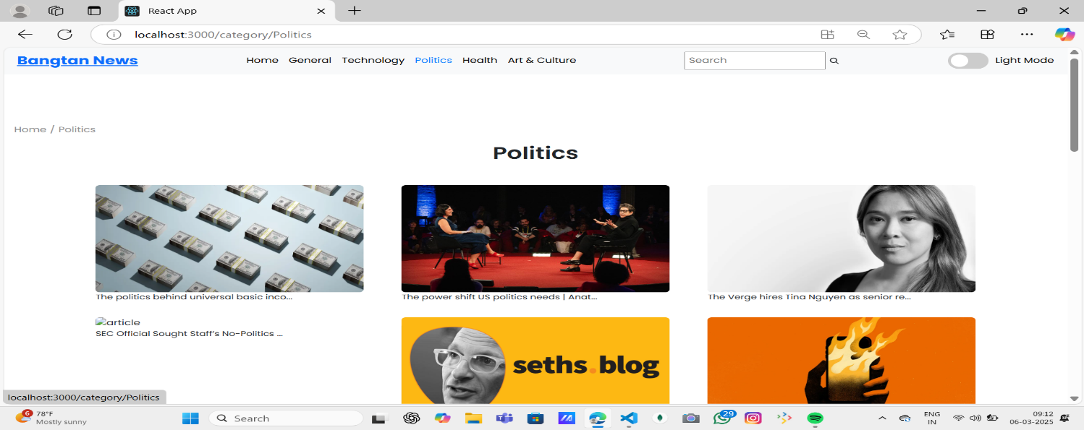

**Redirected Article Page:**

Here’s where you can fully immerse yourself! The article page presents the complete news story, sourced directly from the original provider. To keep you engaged and encourage further exploration, the page may recommend related articles tied to the current topic. These suggestions offer a gateway to a broader range of interconnected information, helping you become a more informed and well-rounded reader.

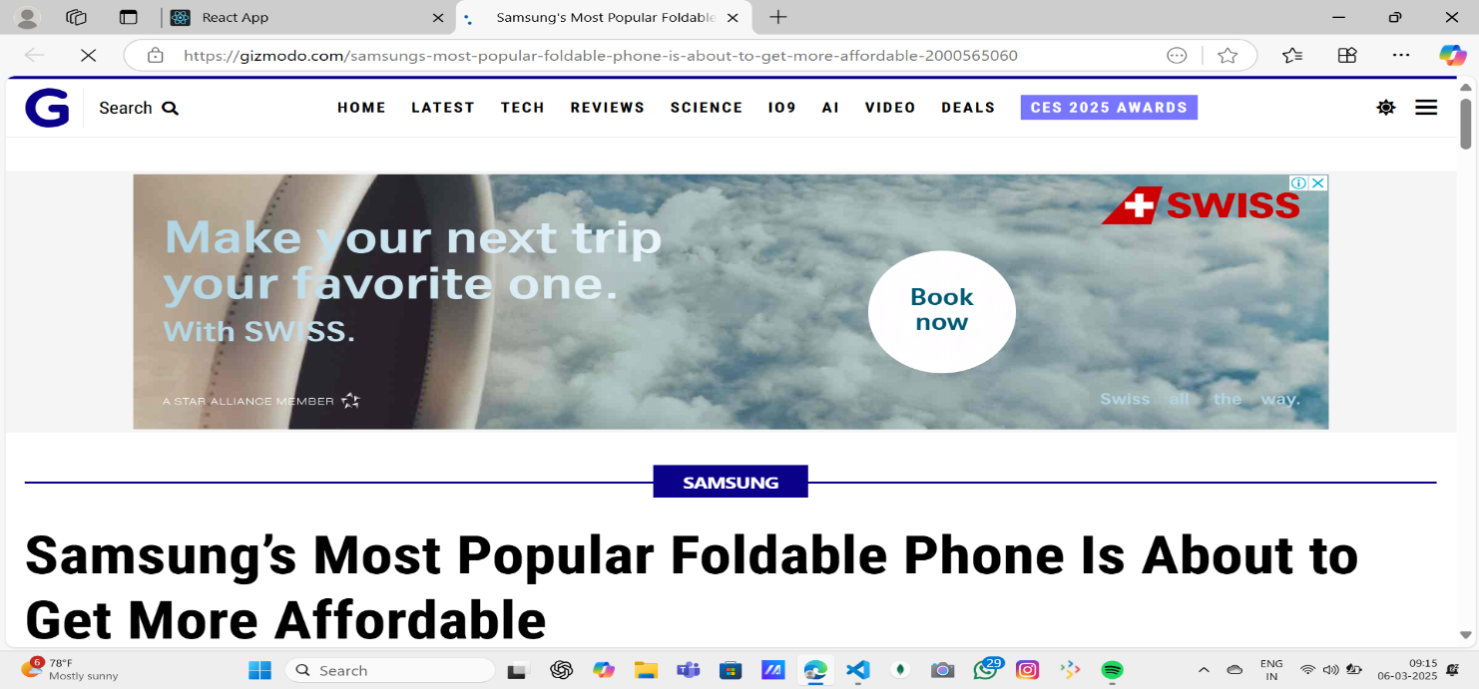

**Dark Mode and Light Mode Implementation:**

This document outlines the process of implementing **Dark Mode and Light Mode Toggle** along with ensuring proper styling for a Newsletter Subscription Section in a React application.

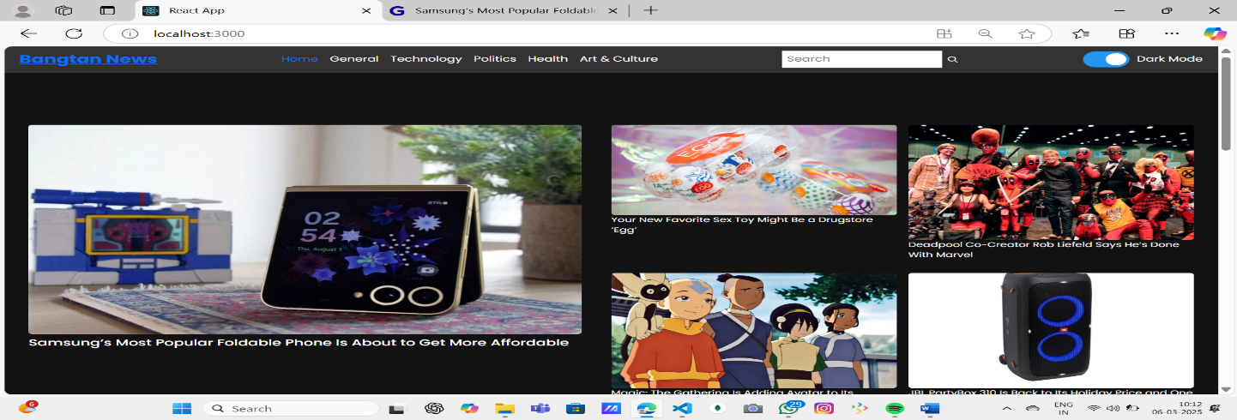

**Project Demo link:**

<https://drive.google.com/file/d/1bgExXP8ALob6TJ2JIxVVsc0Mk5bH-XUJ/view?usp=share_link>

**Project Code link:**

<https://drive.google.com/file/d/167MoKtuKmHdYradNB2HWrM0x-9EyB1QX/view?usp=share_link>